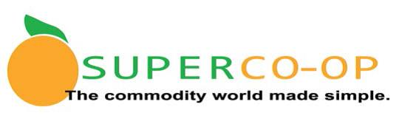**Super Co-Op Frequently Asked Questions (FAQs)**

1. Can I move entitlement $ in/out of DoD?

Yes. Determine how much of your entitlement dollars you want to transfer and contact Cynthia Barcelo at the Super Co-Op office for assistance.

Email: [CynthiaBarcelo@Super-Coop.org](mailto:CynthiaBarcelo@Super-Coop.org) Subject Line: DOD transfer

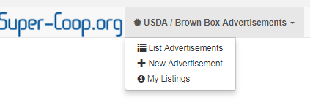2. How do I get rid of Brown Box items I don’t want?

Log-in to your Super Co-Op website account. In the upper left corner of the Member Dashboard screen look for “USDA/Brown Box Advertisements.” Click on “List Advertisements” to view what is available. There may be more than one page so scroll down to the bottom to check. 

In the “Ad Status” it will either say In-storage, On order, or Wanted. In-storage means the product is at the Gold Star warehouse. On order means ordered from USDA but has not arrived at Gold Star yet. Wanted means a district is looking for product.

You can click on the green “Details” button on the right side of the screen to see additional information about the load.

To order, click the box on the far left next to the item you want. A green button will appear at the top of the page – click on “Request Selected Item” to order. If you don’t want the whole lot, you can request the number of cases you want.

You are responsible for storage charges until the item is transferred to another district by request.

3. Why does my entitlement amount change throughout the year?

Your entitlement changes throughout the year due to a number of reasons:

* An estimated entitlement is allocated in January based on your prior year Total Lunches Served (TLS). Once the prior year TLS is finalized in November, the CDE publishes an updated entitlement list, and we adjust your Processed Entitlement accordingly (up or down).
* USDA occasionally cancels loads of brown box due to market conditions and the corresponding entitlement value will be returned to your account.
* Some years we have excess pounds of USDA Foods remaining at our processing manufacturers at the end of the year and the following year we extend additional entitlement to encourage districts to use more processed pounds.
* We also do bi-annual sweeps within the co-op, per our Governing Rules. At the end of January and March we evaluate how districts are spending their entitlement and redistribute entitlement from members who are not spending enough to those who need more. We want to be sure all entitlement funds are spent each year, as they do not carry over from year to year.

4. How do I validate my (Value Pass Through “VPT” or commodity credit) invoices?

It is important that Member Districts verify each processed commodity purchase and delivery. Each time a processed commodity is received, you should check to be sure the proper discount (NOI, FFS, or rebate) was issued and that entitlement was drawn down correctly.

You need three (3) things to validate your Value Pass Through (VPT) or “commodity credit”:

(1) Your invoices for processed commodities

(2) Your distribution bid

(3) The Super Co-Op Price Catalog RFP results (find it at http://www.super-coop.org/rfp.html )

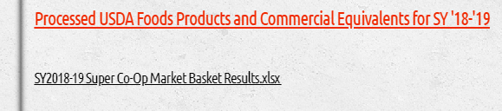

When you receive your processed Commodity, it should be accompanied by an invoice. The invoice should have your delivered price listed. Check this with your local distribution bid to be sure the correct price is charged. Your distributor should show the commodity credit separately on the invoice such as in the example below. Check the Super Co-Op Price Catalog RFP results to be sure the Fee for Service or Net Off Invoice amounts match.

Your cost for delivery from your distribution bid. (Might be included unit price)

Fee for Service price from Super Co-Op Price Catalog RFP Results

Example of Fee for Service (FFS):

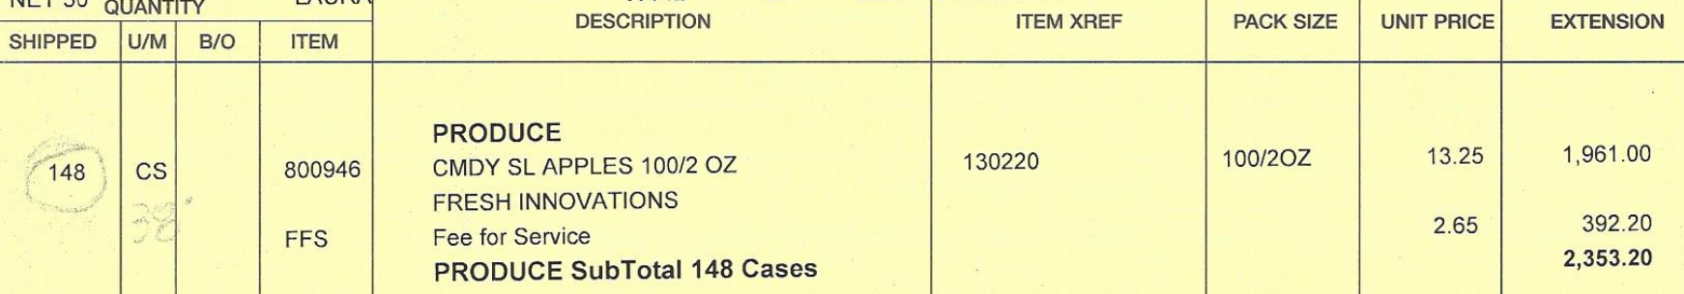

Example of Net Off invoice (NOI)

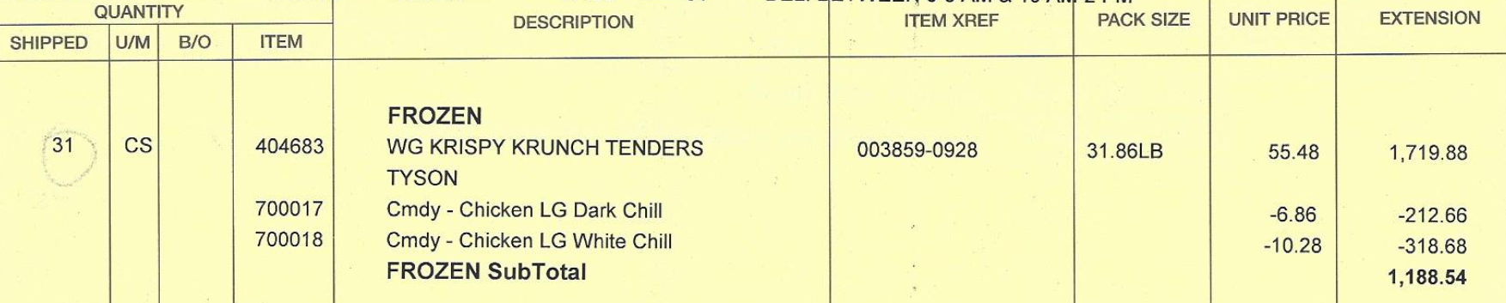

Commercial price from Super Co-Op Price Catalog RFP Results plus your distributor mark-up

USDA Foods Value per case (column N) from Super Co-Op Price Catalog RFP Results

Super Co-Op Price Catalog RFP Results

Commercial price (column U)

Fee for Service Price (column O)

USDA Foods Value per case (column N)

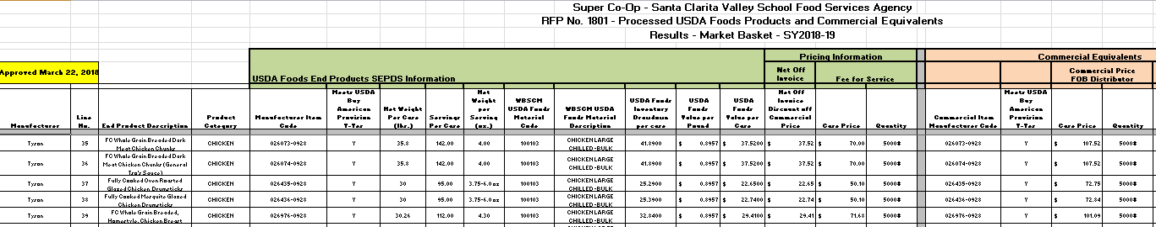

If the numbers don’t match, contact your distributor.

5. What are these storage charges for?

When you leave your brown box at the Gold Star Foods warehouse more than 30 days after they receive the product, you will be charged storage fees (an amount per case each month) per our current contract until you take delivery.

6. How are state fees for processing calculated?

Per the Super Co-Op Governing Rules, state fees for processing are calculated using this process:

Processed USDA Foods State Administrative Fees shall be billed on a quarterly basis.

Member Districts shall be billed their fair share of the State Administrative Fees of USDA Foods delivered to processors during the quarter, based on each district’s entitlement allocated to processing. So to do the calculation, we take the entitlement dollars you have allocated and determine what percent of the entire co-op you are; we multiply that times the fair market value of all the truckloads of USDA Foods that were delivered to processors during that quarter.

7. Why are the state fees for DoD not billed in the same year that DoD was ordered?

The CDE sends the Super Co-Op an annual bill for DoD, usually in July of the following school year after all orders are delivered.

8. Why am I being charged state fees for brown box when I haven’t received them yet?

State fees for brown box are billed monthly to member districts when the product arrives at Gold star Foods, not when you take delivery to your school site. See Question 34 to learn how to determine when the brown box arrived at Gold Star Foods.

9. Why are the brown box amounts on my survey different from the amount of cases that are in my inventory?

The Co-Op must order all products in full truckloads, which are about 1,000 cases each. After you fill out your survey in February/March we add up all the items each district wants and make them into full truckloads. Sometimes we have to add or subtract a few cases per district to make the full truckloads.

10. Why does the brown box for multiple months all come in at the same time?

The Co-Op must order all products in full truckloads, which are about 1,000 cases each. Sometimes there are not enough orders to get a truck each month so we have to combine some orders.

11. Under the entitlement survey I see 50 cases requested for Oct and November. Why am I getting it in January?

See Question 10.

12. Why am I not getting commodity credit?

In order for you to get commodity credit, the following things have to be correct:

★Have entitlement in your account

★Manufacturer has the correct raw product

★Item you want to buy must be listed on Price Catalog RFP

★Distributor identified correctly in K-12 Foodservice or ProcessorLink

If all of these things are correct and you are still not getting your discount, contact your distributor and ask why. (See Question 4 for more info)

13. What is this bill for? (Happens when Quarterly State Fee invoices are sent)

See Question 6, 7 & 8.

14. Does the % on my Dashboard mean what I have left or what I have spent?

It’s what you have left or the remaining amount.

15. How do I know if I’ll have enough money at the end of the year?

If your school year starts in mid-August and ends in mid-June, you can use these percentages as a rough guide: End of October = 30%, end of January = 55%, end of March = 70%

16. How do I spend all my entitlement?

If you don’t spend all of your entitlement this year, take a look at your menu and try to add more brown box or processed items for your menu next year. Sometimes it takes a couple of years of practice to get a good mix of commodity vs. commercial items that your customers will like. Another way to use your entitlement is to set some aside for DoD produce. You can transfer your entitlement back and forth between DoD and processing during the year. See Question 1 for how to do that.

17. What is the Unprocessed Fruit and Vegetable Pilot Program? How do I participate? Should I participate?

The Pilot program is not taking new applicants at this time. When the USDA is taking new applications, the CDE will send out an email notice. To participate, you set aside an amount of your entitlements funds to use to purchase fruits and vegetables from approved vendors. It works well for some of our members, but not for others. If you are interested the next time they take new members, I can put you in touch with some of our Co-Op member districts that use the program and you can ask them for pros and cons on the program.

18. I put in a request online for Brown Box Advertisement and never heard anything back – did I get the item or not?

When you make a request, you should get an automatic email telling you we received your request. Within a week, you should get a personal email from Cynthia Barcelo letting you know if you did or did not get the item requested.

19. Why can’t Brown Box Advertisement be automatic?

It costs quite a bit to re-work the code on the website to make it automatic and we don’t feel it’s worth the investment at this time.

20. Where does Cynthia Barcelo work? Who pays for her salary?

Cynthia is the USDA Foods Program Manager at Gold Star Foods. She works at the Ontario warehouse office. Gold Star Foods pays her salary. Gold Star Foods is the Super Co-Op Administrator by contract (through a formal bid process) and the co-op membership fund pays a monthly fee to Gold Star for specific management duties related to the Super Co-Op.

21. How do I read the Super Coop RFP – what do the different columns mean?

This RFP established pricing from the manufacturer (processor) to your distributor. Your distributor will add on a fee or percent to cover their receiving and delivery costs. See the response to Question 4 for an overview of the most important columns on the spreadsheet and how to use them.

21. What is DF?

“DF” stands for “Donated Food” or raw commodity product.

23. How do I fill out my entitlement survey?

There is a recorded webinar on the Super Co-Op website at [www.super-coop.org](http://www.super-coop.org) – the Home page.

 Click on the link to start.

24. What is the difference between NOI and FFS?

Fee for Service (FFS) is the price of the product net the commodity value.

Net Off invoice (NOI) is the commercial price less the commodity value.

25. Do I have to purchase from Gold Star Foods if I am a member of Super Coop?

Gold Star Foods won the bid and is the current distributor for USDA Foods Direct Delivery (aka brown box), so all of those items have to be delivered by Gold Star. You should be using local procurement methods (your own bid) to determine a distributor for processed USDA Foods (processed commodity) and other commercial products.

26. How do I know if I’m getting my commodity credit? How do I verify this with my distributor?

See Question 4.

27. When do entitlement sweeps happen?

The Lead Agency and/or Administrator will reassign unused entitlement using the following schedule:

January 31 – Member Districts with more than 60% remaining entitlement will have the excess funds removed (“swept”) and given to districts with less than 60% remaining.

March 30 – Member Districts with more than 30% remaining entitlement will have the excess funds removed (“swept”) and given to districts with less than 30% remaining.

28. What percentage entitlement can I overspend?

We usually give 10%.

29. Does entitlement carryover?

No, you need to use your entitlement in the year it is received.

30. Is there a fee to be part of the Super Coop?

There is an annual membership fee that is 0.3% of your annual entitlement, billed in July by the Lead agency (San Mateo-Foster City School District).

31. Can I use entitlement dollars to pay for Brown Box Storage? Why not?

Entitlement dollars are “in-kind” funds we receive from the federal government and not real cash that can be used as monetary exchange.

32. What do I spend my entitlement dollars on?

You can spend your entitlement on USDA Direct Delivery (aka brown box), processed end products, DoD Fresh Produce, or the Unprocessed Fresh Fruit and Vegetable Pilot. If you have extra entitlement in the spring, you can move entitlement from processing to DoD (Also see Questions 1 and 16).

33. What is live inventory vs Entitlement usage?

Your live inventory is the brown box you currently have in stock at Gold Star Foods (on the Gold Star Foods website). Your entitlement usage is the entitlement dollar value of the USDA Foods you have received during the year (on the Super Co-Op website).

34. Where is my current commodity Brown Box inventory?

You can find your current brown box inventory on the Gold Star Foods website. Go to [www.goldstarfoods.com](http://www.goldstarfoods.com) and click on “Order online.” Log-in to your account (For username and password setup, please contact [HelpDesk@GoldStarFoods.com](mailto:HelpDesk@GoldStarFoods.com)). On the left side of the screen, scroll down to “Reports.” The “USDA Live Inventory” tab will show you what you have in stock. For additional information, click on “USDA Inventory by Lot” and you will be able to see the date the items were received and when storage charges will begin if you don’t ship before that date.

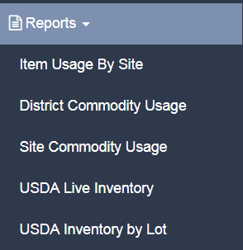

35. Who is my representative on the Governing Council and how to do I contact them?

|  |  |  |
| --- | --- | --- |
| **Regional Group** | **Director / Contact** | **District** |
| **Lead District** | **Andrew Soliz** | **San Mateo-Foster City School District** |
|  | (650) 312-1968 | asoliz@smfc.k12.ca.us |
| Region 2 | Amy Hedrick-Farr | Santa Cruz City School District |
|  | (831) 429-3850 | ahedrick-farr@sccs.net |
| Region 3 | Alissa Angle | Central Unified School District |
|  | (559) 274-4700 ext. 63108 | aangle@centralusd.k12.ca.us |
| Region 4 | Stephanie Gillenberg | Oxnard Union High School District |
|  | (805) 385-5749 | Stephanie.Gillenberg@ouhsd.k12.ca.us |
| Region 5 | Léna Agee | Manhattan Beach USD |
|  | (310) 318-7345 x5031 | LAgee@manhattan.k12.ca.us |
| Region 6 | Michelle Curry | South Pasadena USD |
|  | (626) 441-5820 x 2950 | mcurry@spusd.net |
| Region 7 | Liz Brown-Smith | Whittier Union High SD |
|  | (562) 698-8121 x 1092 | Liz.Brown-Smith@wuhsd.org |
| Region 8 | Daryl Hickey | Pomona USD |
|  | (909) 397-4711 x 21100 | Daryl.Hickey@pomona.k12.ca.us |
| Region 9 | Stephanie Bruce | Palm Springs USD |
|  | (760) 322-4117 | sbruce@psusd.us |

Regional Group List for SY2019-20



36. How do I join the Super Co-Op?

Membership is granted to districts by vote of the Governing Council. There is an Application for Membership that must be received by the Super Co-Op by mid November to be considered for membership for the following school year. The Governing Council typically meets the last week of November to consider new district memberships; districts will be notified of the results by December 10th. Districts should be prepared to complete an Assignment of USDA Foods contract immediately after approval for membership. The application packet is posted at [www.super-coop.org](http://www.super-coop.org) in September of each year.

No action is required for agencies electing to continue to participate through their current method.

37. What is the difference between the State Coop and Super Coop? Why should I be in one vs. the other?

At the end of this document is a 2 page chart published by the CDE Food Distribution Program titled AVENUES FOR RECEIVING U.S. DEPARTMENT OF AGRICULTURE (USDA) FOODS that may assist you in making this decision.

Additionally, the FDP has posted a recorded Webinar titled CDE Food Distribution Program: Avenues of Participation, located on the YouTube CDE Nutrition Program Web page at <https://www.youtube.com/watch?v=qKELfrbsd40> . This Webinar provides an overview of the three different avenues for receiving USDA Foods in California.

California Department of Education Food Distribution Program

Nutrition Services Division

***Food Distribution Program***

***AVENUES FOR RECEIVING U.S. DEPARTMENT OF AGRICULTURE (USDA) FOODS***

|  |  |  |  |
| --- | --- | --- | --- |
| **CHARACTERISTIC** | **STATE DISTRIBUTION CENTER (SDC) AGENCIES** | **STATE COOPERATIVE (Co‑op) MEMBERS** | **PRIVATE COOPERATIVE**  **(DIRECT SHIP) MEMBERS** |
| Organization | Agencies receiving USDA Foods through an SDC are part of the Allocation and Advance Order System. Agencies control expenditure of their entitlement. Agencies are responsible for management of their USDA Foods. | Member agencies may operate independently or as part of a collective group. There is no Lead District. State representatives oversee the program. Members control expenditure of their entitlement and are responsible for management of their USDA Foods. There is no minimum average daily participation (ADP) required. | One member agency assumes the responsibility as the Lead District. Co‑op members assign their USDA Foods entitlement and responsibility for related management activities to the Lead District. The combined Co‑op member’s ADP must be a minimum of 50,000 to qualify as a Direct Shipment agency. |
| Ordering | Agencies order non‑processed USDA Foods based on the quantity available at the SDC at least five times a year. Annually, before each new school year, agencies have the opportunity to order USDA Foods for processing through the Advance Order. Agency Advance Orders to processors are combined with State and Private Co‑op orders in order to make up full truckloads. | Member agencies submit a completed Order Form (pre‑planner) prior to the beginning of the school year. USDA Foods for direct shipment to a processor are designated when USDA Foods are ordered. USDA Foods allocations are based on the agency’s “fair share” of the state total. | The Lead District is responsible for ordering and allocating entitlement to member districts. Orders for USDA Foods are submitted as surveys are released from USDA. USDA Foods for direct shipment to a processor are designated when USDA Foods are ordered. USDA Foods allocations are based on the Co‑op’s “fair share” of the state total. |
| Receiving, Storage, and Distribution | Shipments of USDA Foods are designated for delivery to the SDC or processor. Delivery dates for warehoused USDA Foods are indicated on the Allocation. All USDA Foods inventory is maintained in the agency’s name. Extended storage is available at the SDC. | Shipments of USDA Foods are designated for delivery to the SDC or processor. Deliveries are scheduled by the SDC with the individual member agency. Co‑op member orders to processors are combined with the Advance Order and Private Co‑op orders. Extended storage and frequent deliveries are available. All inventory and entitlement is maintained in the member agency’s name. | Shipments of USDA Foods are delivered to a designated warehouse, distributor, or processor. Orders have a quarter load minimum and must be combined with other orders to equal a full truckload. Delivery to individual member agencies and extended storage is arranged with the distributor. All USDA Foods inventory and entitlement is maintained in the Lead Agency’s name until allocated to the member agency. |

Last Reviewed: March 2019 Page 1 of 2

***Food Distribution Program***

***AVENUES FOR RECEIVING USDA FOODS***

|  |  |  |  |
| --- | --- | --- | --- |
| **CHARACTERISTIC** | **STATE DISTRIBUTION CENTER AGENCIES** | **STATE COOPERATIVE MEMBERS** | **PRIVATE COOPERATIVE**  **(DIRECT SHIP) MEMBERS** |
| Charges | Agencies requesting shipment of raw USDA Foods for direct shipment to a processor are charged $0.90 per case equivalent. Service, shipping and handling charges are $2.85 per case for USDA Foods and for finished product from a processor delivered through the SDC. A discount is offered for agencies picking up their USDA Foods from the SDC. Extended storage fees at the SDC vary, depending on the type of storage required. | Agencies requesting shipment of raw USDA Foods for direct shipment to a processor are charged $0.90 per case equivalent. Service, shipping and handling charges are $2.85 per case for USDA Foods and for finished product from a processor delivered through the SDC. A discount is offered for agencies picking up their USDA Foods from the SDC. Extended storage fees at the SDC vary, depending on the type of storage required. | The state charges the Co‑op an administrative fee of $0.90 per case for direct shipment of USDA Foods to commercial distributors and/or processors. Distributors may charge additional fees for services, shipping and handling, and storage of USDA Foods. Please contact the Private Co‑ops directly regarding their fees. |
| Department of Defense Fresh Fruit & Vegetable Program (DOD) | Agencies use a portion of their entitlement to order selected seasonal DOD produce through the allocation process. Agencies receive DOD as part of their regular allocation. Agencies are charged $2.85 for each case of produce delivered through the SDC. | South State Co‑op members use a portion of their entitlement to order and receive seasonally selected DOD produce and are charged $2.85 for each case of produce delivered through the SDC. North State Co‑op members use a portion of their entitlement to order and receive domestically grown produce directly from the DOD as needed and a $0.15 administrative fee is assessed by the state for each case of produce delivered. | Private Co‑ops and direct ship agencies use a portion of their entitlement to order domestically grown fresh fruits and vegetables directly from the DOD as needed. A private distributor delivers DOD produce to each agency. The state charges the Co‑op an administrative fee of $0.15 for each case of produce delivered. Please contact the Private Co‑ops directly regarding their fees. |
| USDA Food Losses and Transfers | Agencies are responsible for management of their USDA Foods. USDA Foods losses at a processor must be reported to the state and may require USDA approval. USDA Foods transfers between recipient agencies are allowed without prior state approval; however, transfers involving a processor require state agency approval. | Individual members are responsible for management of their USDA Foods. USDA Foods losses at a processor must be reported to the state and may require USDA approval. USDA Foods transfers between recipient agencies are allowed without prior state approval; however, transfers involving a processor require state agency approval. | Individual members are responsible for management of their USDA Foods. USDA Foods losses at a processor must be reported to the state and may require USDA approval. USDA Foods transfers between recipient agencies are allowed without prior state approval; however, transfers involving a processor require state agency approval. |